Pinkvilla
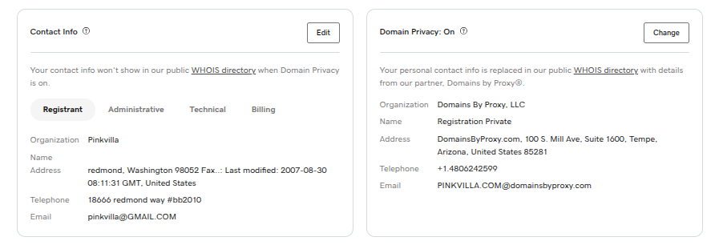
Hindirush
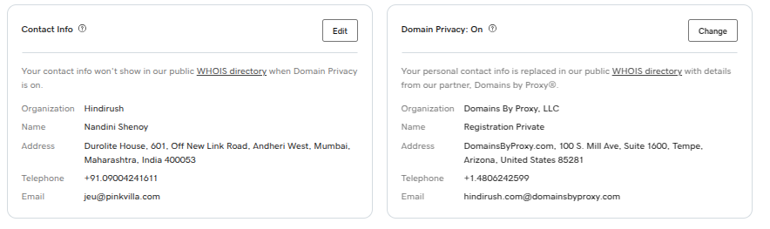
17looms.com
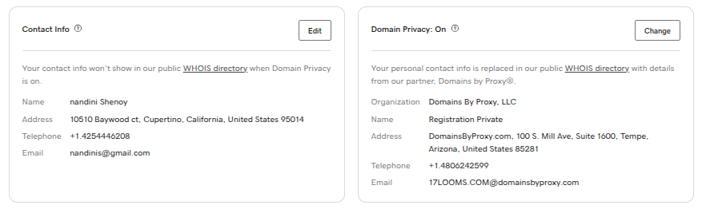

17looms.in
